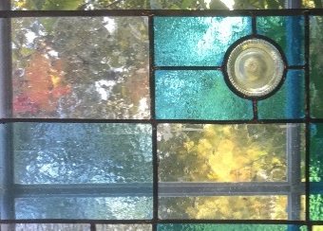
Stained Glass for Beginners
Learn the basic techniques involved in making leaded glass pieces and create a small decorative panel that you could use as a suncatcher or small window. **
The stained-glass starter course will take place over 2 full days sessions: 2nd & 4th August 2021 10am-4pm. (additional sessions may be needed if you select a more complex design for your glass panel) Cost of the basic course is 125€ + materials
Session 1 will cover an introduction to the different types of glass, lead came, solder, tools & equipment and some basic glass cutting techniques. You will then look at how to design a pattern for a stained-glass piece. During the afternoon we will start creating your design and begin making the piece. We have various examples and designs available for you to use/copy/adapt and to give you inspiration if you want to create your own design. Your panel can be up to the size of A4. (note that some design ideas may not be suitable for a small glass piece – designs will be discussed a couple of weeks before the course so that glass can be ordered in in advance)
**There will be options available from very simple geometric designs and ideas for complete beginners to intermediate designs if you want a bit more of a challenge or have some experience already. The cost of the materials (and any additional tuition) will depend on which design you chose. This course does not cover glass fusing or copper foil (Tiffany) techniques.
You will then begin putting together your design with guidance.
Your panel will start to develop and you should be able to start cutting the lead and pinning your pieces together.
Session 2 You will continue working on your piece and you should reach the point where you can solder your piece together and start the process of cementing. Those that have selected a more complex piece or who need extra time can book onto additional sessions if necessary. These additional sessions will incur a tuition fee of 30€ per 3-hour session.
Please note that Stained glass art does require a steady hand and plenty of patience and perseverance. There is also a fairly high risk of minor cuts when handling glass.
Because we want you to have some choice in what you make, and different types and colours of glass cost varying amounts the materials are sold separately to the basic tuition fee. You can purchase your own materials or buy them from Le Jardin creative who will supply glass, lead and solder at cost price*. If we have to order in additional glass, different colours etc then the postage cost will be included. The glass and lead pieces will be sold as ‘hobby size’ or half hobby size pieces. (average cost of an A4 piece is 20-25€)
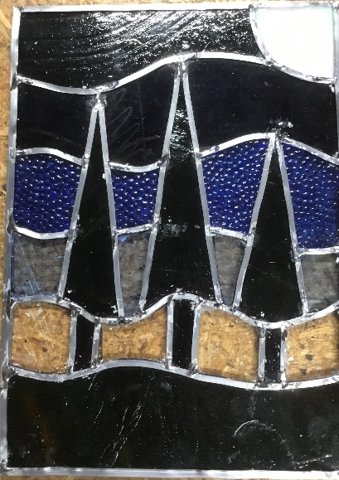
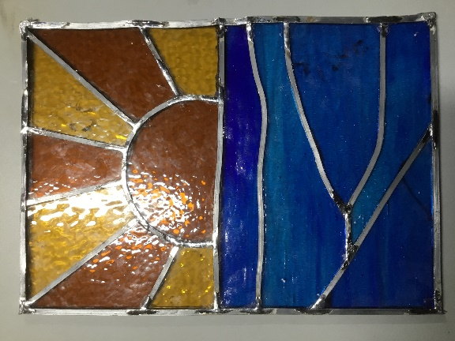
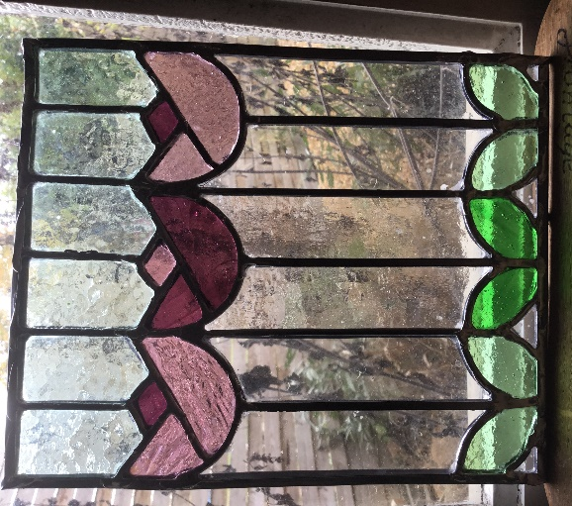
How to Find us:
Le Jardin Créatif is located in the hamlet of La Guinandie which is off the D34 running from Vayres to Saint Laurent sur Gorre. You can find it easily by searching for La Guinandie on google maps, Le Jardin Créatif is also pinned on google maps and we now have a signboard to direct you off the D34 at the turning to La Guinandie. There will be signage to follow when you get into the hamlet. We have parking available on our drive and outside the barn: https://www.google.co.uk/maps/place/Le+Jardin+Creatif/@45.7604714,0.8303098,17z/data=!3m1!4b1!4m5!3m4!1s0x47feef428376f0ff:0x49ee00b063644007!8m2!3d45.7604677!4d0.8324985
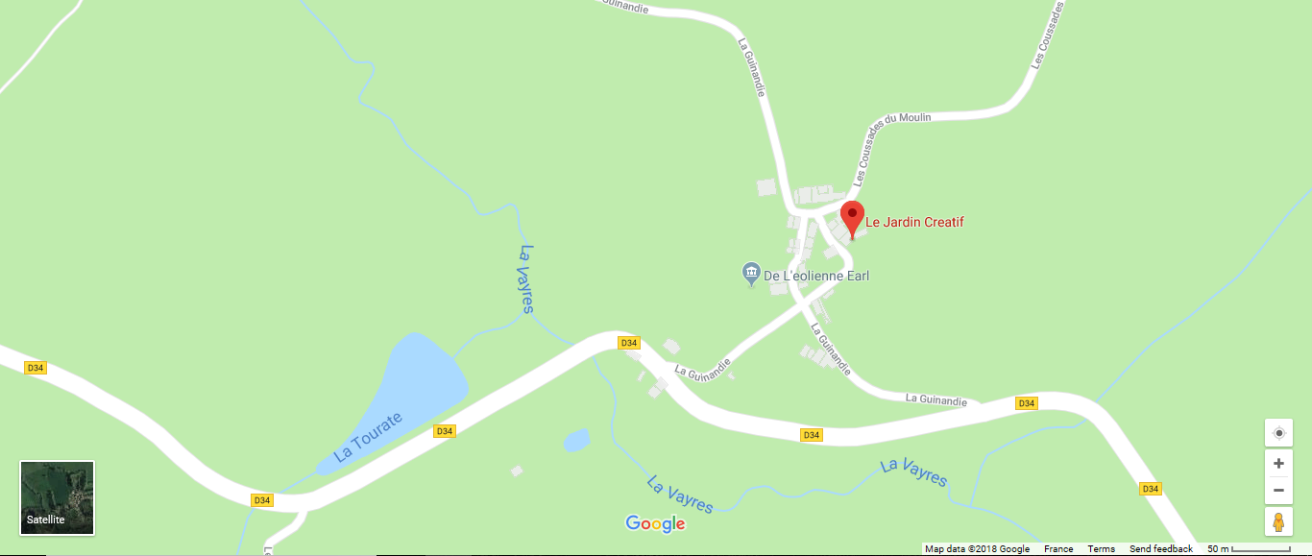
What to Bring:
You may want to take notes during the day so bring a notebook, you will need a pen and pencil for drawing and you can bring along pictures and ideas for your glass design – note that some ideas may not be suitable for creating in glass or may be too complex for this basic course. A camera or a phone with a camera on it is also useful so you can take pictures during the sessions which will help you to recall the techniques and principles.
We are also offering intermediate level bespoke courses for making larger pieces – a small exterior window for example – Dates to be confirmed according to demand
Please let us know if there is anything we need to be aware of in terms of your health and abilities such as any allergies, illness or disability that may affect what you can do on the course or that we should be aware of for your health and safety.
Finally, we are really looking forward to meeting you and to an enjoyable day sharing our knowledge and passion for crafts.
We look forward to seeing you in August,
Kind regards
Caroline and Paul

